Epsom & Ewell
2
v
Godalming Town
Tuesday, 20th August 2019 – 7.45 p.m.
Good evening and welcome to High Road for our second home match of the season. We welcome the players, supporters and officials of Godalming Town who last visited back in February when we defeated them handsomely in the League Cup by five goals to one. Also last December we edged a 3-2 win here in the League when we trailed 2-0 after just five minutes, requiring the first of what would become three separate incidents of “Stanchiongate” to fall in our favour within two months. We also won 3-1 in Godalming last season to complete a fine treble. Here’s hoping for more of the same tonight!

Godalming Town are Managed by our former keeper Les Cleevely, although even he may not remember the time here that well as it was a brief stop on his career path. Despite his fine performances between the posts we were relegated at the end of 1986/87. It must be pointed out that we did actually win five of the seven matches that he played in, but the damage had been done earlier in the season and we went down, despite a young defender by the name of Matt Elliott being in our team at the time and also playing in all seven of those matches. I wonder what happened to him!

We were last here on the opening day of the season when we fell away badly to lose 3-5 to Fleet Spurs after dominating the first half. Since then, we visited Camberley Town for a League match with Bagshot the following Saturday, where we were narrowly defeated 2-1 with a late goal, but then we visited Chessington & Hook United for a match with their tenants, the newly promoted Westside, and finally opened our account for the season with a convincing 3-1 win that in all honesty should have been about 6-0, such was our dominance.

Going forward, we have no fixture this Saturday and our next match comes in seven days when we welcome one of the promotion favourites Tooting Bec to High Road.

Finally, we’d like to thank long-serving supporter Paul Merritt, who is sponsoring today’s match. He has been a supporter since 1975 and has written an article for today’s programme relating to his first memories at the club. This offer is open to any supporter or player, as we all had a first match at some point, so don’t be shy, drop me a line. Thanks to Paul for his sponsorship. Many other matches remain so please get in touch and choose your match.

Enjoy the game!

Rich

You can follow us on social media – just see the inside cover for details.

Cover photo by Gemma Jarman

Chaz-Lee Martin opens his account for the season on his debut with a fine downward header to put us 1-0 up in the match against Fleet Spurs on Saturday 3rd August.

Cherry Red Records Combined Counties League
Division One Table 2019/20
incl Saturday 17th August | P | W | D | L | F | A | Pts | GD | H | A

Jersey Bulls | 3 | 3 | 0 | 0 | 14 | 0 | 9 | +14 | 13/4 | 16/11
Fleet Spurs | 3 | 3 | 0 | 0 | 10 | 5 | 9 | +5 | 3-5 | 7/12
Sandhurst Town | 3 | 2 | 1 | 0 | 5 | 3 | 7 | +2 | 9/11 | 14/3
Westside | 3 | 2 | 0 | 1 | 9 | 3 | 6 | +6 | 28/12 | 3-1
Chessington & Hook Utd | 3 | 2 | 0 | 1 | 7 | 3 | 6 | +4 | 22/2 | 12/10
Farnham Town | 2 | 2 | 0 | 0 | 4 | 1 | 6 | +3 | 28/9 | 15/2
Bagshot | 3 | 2 | 0 | 1 | 5 | 4 | 6 | +1 | 4/4 | 1-2
AFC Hayes | 2 | 1 | 1 | 0 | 10 | 6 | 4 | +4 | 21/9 | 18/1
Cove | 2 | 1 | 1 | 0 | 5 | 3 | 4 | +2 | 25/1 | 5/10
British Airways | 3 | 1 | 1 | 1 | 7 | 6 | 4 | +1 | 11/1 | 29/2
Walton & Hersham | 1 | 1 | 0 | 0 | 3 | 0 | 3 | +3 | 31/3 | 2/11
Kensington & Ealing Boro | 3 | 1 | 0 | 2 | 6 | 6 | 3 | 0 | 26/10 | 4/1
Epsom and Ewell | 3 | 1 | 0 | 2 | 7 | 8 | 3 | -1 | x | x
Dorking Wanderers Res | 3 | 1 | 0 | 2 | 5 | 6 | 3 | -1 | 23/11 | 11/4
Bedfont & Feltham | 3 | 1 | 0 | 2 | 3 | 4 | 3 | -1 | 14/12 | 18/4
Tooting Bec | 2 | 0 | 2 | 0 | 4 | 4 | 2 | 0 | 27/8 | 12/11
Eversley & California | 3 | 0 | 0 | 3 | 0 | 8 | 0 | -8 | 21/3 | 21/12
Godalming Town | 3 | 0 | 0 | 3 | 4 | 13 | 0 | -9 | 20/8 | 30/11
Ash United | 3 | 0 | 0 | 3 | 4 | 14 | 0 | -10 | 8/2 | 7/9
FC Deportivo Galicia | 3 | 0 | 0 | 3 | 0 | 15 | 0 | -15 | 19/10 | 1/2

Lucky Day? – 20th August
Played 14 - Won 6 Drawn 4 Lost 4 - For 21 Against 19 - PPG 1.57 - Above Average
Our Club record against the modern Godalming Town club
Played 6 - Won 5 Drawn 0 Lost 1 - For 15 Against 9 - PPG 2.50 - Fantastic
Our Largest wins and losses against Godalming Town
12th February 2019 - W 5-1 - Combined Counties League Cup (H)
21st November 2017 - L 0-3 - Combined Counties League (H)
Godalming Town’s Last Visit
12th February 2019 - Won 5-1 - Combined Counties League Cup

Paul Merritt – My First Match
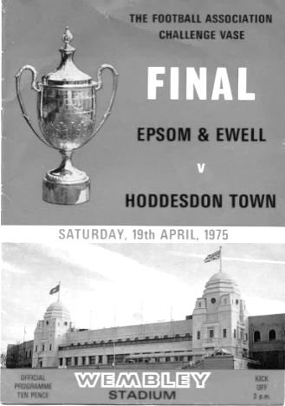
I have been supporting Epsom & Ewell regularly since 1975 and my first match was the F.A. Vase Final in April of that year.

I went to Wembley Stadium that day in my dad's car; it was a mustard yellow Rover 2200TC. We parked in the car park directly outside the stadium; I can't imagine doing that today! We paid at the turnstile and sat on the same side as the Royal Box. I also recall at the time, Bye Bye Baby by the Bay City Rollers was at Number 1. I was not a fan of the Bay City Rollers!

My first Epsom & Ewell home game was against Southall & Ealing Borough in an F.A. Cup 1st Qualifying Replay on Wednesday 17 September 1975. It was played in the afternoon as West Street back then had no lights.

I had only just started at Cheam High School who on that particular Wednesday gave me some homework, but instead of doing that when I got home, I decided to get on my bike, and cycle the two miles as fast as I could to West Street, still wearing my uniform, as an F.A. Cup Replay involving Epsom & Ewell was much more exciting than homework!

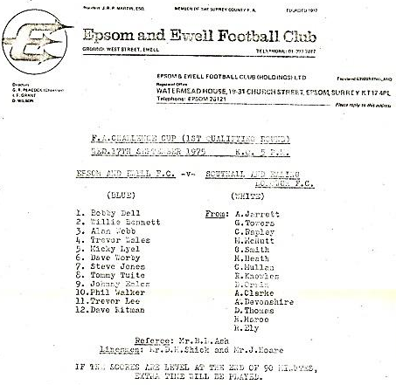
I stood along the side terrace that was opposite the main stand. Standing close by me that day was the then Millwall manager, Gordon Jago, who as we all know, was looking at Trevor Lee and, Phil Walker, while playing for Southall that day was future West Ham player and current Maidenhead United manager, Alan Devonshire. The programme for the match that day was a single sheet.

The game finished 3-3 AET, but we lost 5-1 in the second replay, held at Dulwich Hamlet’s famous old Champion Hill ground, but they were three divisions above us, so we had already done well to take them to the replays. Number 1 that day was Sailing by Rod Stewart!

I think I've known Richard, for at least 30-40 years, first meeting him when he opened the Caravan Club Shop by the main entrance (1985 - Ed). I remember him having all the Epsom & Ewell programmes for sale from the recent away games too.

A club shop, our own ground, a new clubhouse and, a decent standard of football, ah, those were the days!

First Eleven Appearances - (max 3)
Name | Debut | 2018/19 |  |  |  | Career Totals
 |  | App | Sub | Tot | Goals | App | Sub | Tot | Goals
BENNETT Bobby | 12/08/2018 | 1 | 1 | 2 | 0 | 42 | 1 | 43 | 23
BONASS-WARD Joe | 10/08/2019 | 2 | 0 | 2 | 0 | 2 | 0 | 2 | 0
CARNEY Billy | 12/01/2019 | 1 | 1 | 2 | 1 | 13 | 6 | 19 | 7
CARTON Kyle | 03/08/2019 | 1 | 0 | 1 | 0 | 1 | 0 | 1 | 0
CHIN Louis | 08/12/2018 | 1 | 0 | 1 | 0 | 14 | 1 | 15 | 0
CONNELLY Lloyd | 14/10/2017 | 3 | 0 | 3 | 0 | 81 | 4 | 85 | 6
DAVIES Felix | 03/08/2019 | 3 | 0 | 3 | 0 | 3 | 0 | 3 | 0
FUNNELL Toby | 03/08/2019 | 3 | 0 | 3 | 0 | 3 | 0 | 3 | 0
GALLAGHER Jordan | 07/08/2016 | 3 | 0 | 3 | 1 | 52 | 13 | 65 | 19
HEAGNEY Adam | 16/08/2016 | 1 | 0 | 1 | 0 | 115 | 13 | 128 | 3
HENDRY Rob | 08/08/2015 | 1 | 1 | 2 | 1 | 111 | 25 | 136 | 47
LEWIS Rory | 03/08/2019 | 1 | 1 | 2 | 0 | 1 | 1 | 2 | 0
MARTIN Chaz-Lee | 03/08/2019 | 2 | 0 | 2 | 2 | 2 | 0 | 2 | 2
MURPHY Scott | 20/01/2007 | 2 | 0 | 2 | 0 | 93 | 2 | 95 | 9
MURPHY Todd | 27/11/2018 | 1 | 0 | 1 | 0 | 4 | 9 | 13 | 0
NIGHTINGALE Zak | 03/08/2019 | 0 | 1 | 1 | 0 | 0 | 1 | 1 | 0
ROBERTS Liam | 12/08/2017 | 1 | 2 | 3 | 1 | 51 | 23 | 74 | 18
ROBINSON Jake | 23/02/2019 | 2 | 0 | 2 | 0 | 11 | 1 | 12 | 0
SMITH Taryn | 28/10/2017 | 2 | 0 | 2 | 1 | 16 | 11 | 27 | 6
SULLIVAN Ryan | 04/08/2018 | 1 | 0 | 1 | 0 | 31 | 2 | 33 | 0
THOMPSON Ashley | 21/08/2017 | 1 | 0 | 1 | 0 | 36 | 1 | 37 | 5
WHITE Sean | 02/08/2014 | 0 | 1 | 1 | 0 | 29 | 26 | 55 | 9

Latest Results and Fixtures
Combined Counties League – Saturday 3rd August
Bedfont & Feltham | 3-0 | Bagshot
Cove | 3-3 | AFC Hayes
Dorking Wanderers Reserves | 1-4 | British Airways
Epsom & Ewell | 3-5 | Fleet Spurs
Farnham Town | 3-1 | Kensington & Ealing Borough
Godalming Town | 2-4 | Chessington & Hook United
Jersey Bulls | 3-0 | Ash United
Sandhurst Town | 1-1 | Tooting Bec
Walton & Hersham | 3-0 | Eversley & California
Westside | 6-0 | FC Deportivo Galicia
Emirates F.A. Cup – Extra Preliminary Round – Saturday 10th August
AFC Hayes | 1-1 | Wembley
Fleet Town | 2-2 | Farnham Town
Guildford City | 3-2 | Tooting Bec
Walton & Hersham | 2-4 | Southall
Combined Counties League – Saturday 10th August
Ash United | 1-4 | Dorking Wanderers Reserves
Bagshot | 2-1 | Epsom & Ewell
British Airways | 0-2 | Cove
Latest Results and Fixtures
Combined Counties League – Saturday 10th August
Chessington & Hook United | 3-0 | Bedfont & Feltham
Eversley & California | 0-2 | Westside
Fleet Spurs | 4-2 | Godalming Town
Kensington & Ealing Borough | 2-3 | Sandhurst Town
F.A. Cup – Extra Preliminary Round Replays – Tuesday 13th August
Wembley | 3-2 | AFC Hayes
Farnham Town | 1-2 | Fleet Town
Combined Counties League – Wednesday 14th August
FC Deportivo Galicia | 0-6 | Jersey Bulls
Combined Counties League – Saturday 17th August
AFC Hayes | 7-3 | Ash United
Bagshot | 3-0 | FC Deportivo Galicia
Bedfont & Feltham | 0-1 | Farnham Town
Cove | 1-1 | Walton & Hersham
Match abandoned after 49 minutes after a serious player injury for Cove
Dorking Wanderers Reserves | 0-1 | Fleet Spurs
Godalming Town | 0-5 | Jersey Bulls
Kensington & Ealing Borough | 3-0 | Eversley & California
Sandhurst Town | 1-0 | Chessington & Hook United
Tooting Bec | 3-3 | British Airways
Westside | 1-3 | Epsom & Ewell
Combined Counties League – Tuesday 20th August
Epsom & Ewell | V | Godalming Town
Combined Counties League – Saturday 24th August
AFC Hayes | V | FC Deportivo Galicia
Ash United | V | Cove
British Airways | V | Bedfont & Feltham
Chessington & Hook United | V | Westside
Eversley & California | V | Bagshot
Farnham Town | V | Sandhurst Town
Walton & Hersham | v | Kensington & Ealing Borough
Combined Counties League – Sunday 25th August
Jersey Bulls | V | Fleet Spurs
Combined Counties League – Monday 26th August
Bagshot | V | Ash United
Bedfont & Feltham | V | AFC Hayes
Cove | V | Farnham Town
Dorking Wanderers Reserves | V | Chessington & Hook United
Godalming Town | V | Walton & Hersham
Sandhurst Town | V | Eversley & California
Westside | V | Jersey Bulls
Combined Counties League – Tuesday 27th August
Epsom & Ewell | V | Tooting Bec
FC Deportivo Galicia | V | British Airways

From behind the goal
Epsom & Ewell 3-5 Fleet Spurs
Combined Counties League Division One - Saturday 3rd August 2019

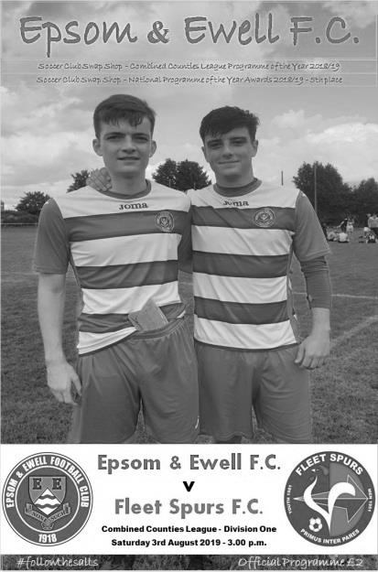
Brand new season - same old story!

It would be very easy to look at the score line of this match and assume that the fault for losing this match was in the defence, but that would not be relating all the facts. The real problem here is one that haunted us for much of the last quarter of the previous season, one of availability, leading to a number of changes to our line up from week to week.

Every team has issues at this stage of the season with holidays, particularly when the players have children, and we had a number absent, including almost an entire midfield missing, as well as the absence of two of our expected first team regulars Sean White and Reisse Griffin through injuries sustained in pre-season. Other un-named players chose at short notice to be unavailable, despite knowing our shortage for this match. Fortunately Ryan Sullivan re-joined us during the week after spending the pre-season at Chipstead and he came straight into midfield alongside the returning Ashley Thompson, although both faded as the match went on after a strong start, probably as a consequence of a lack of match fitness on a warm day.

We had four players making their debut, whilst the visitors only fielded three of the eleven starters who took the field for our last meeting in April and we started significantly the brighter of the two teams. Toby Funnell on the right wing sent in a low ball that Liam Roberts tried to flick into the net but was just wide of the near post in the opening minute, whilst Funnell then had a great opportunity six minutes later when a great reverse pass put him through on goal but his shot from six yards was blocked away by the well positioned Michael Cadle in the Fleet goal.

We also had a couple of free kicks which were won by our new centre-back Chaz-Lee Martin and it was clear he was going to be a threat at every set piece and so it proved in the 12th minute when a deep Roberts corner was met by a powerful downward header from our new player as he buried the ball into the net.

This was the least we deserved at this point and Roberts saw his shot half blocked. We had a small scare on the 20 minute mark when a deep ball over our defence was volleyed back across goal and out for a goal kick from about 12 yards, but we responded well and a clever Rob Hendry pass put Roberts through, only for him to step on the ball in the act of shooting and a minute later when his shot from a good position was scuffed somewhat, but the unusual contact almost caught Cadle out and he only just managed to get enough on the ball to divert it inches wide of his post. However, all our good work to this point was wiped out when Jamil Salah found himself in space just twelve yards out and whilst his shot appeared to lack pace, it took a wicked deflection off a defender and wrong-footed our new keeper Felix Davies as it trickled into the opposite corner of

the goal. As was so often the case last season, we were a bit flaky for about ten minutes but we didn't concede and were back on top as the half expired and had another good opportunity before half time when a Funnell header reached Jordan Gallagher whose shot on the turn just cleared the bar from 12 yards.

The second half was extremely disappointing. It got off to an awful start when our new left back Kyle Carton took a nasty slip out on the touchline, conceding a throw on in the process. Understandably he was unable to get back in position quickly enough, but no one covered him and directly from the throw Salah received the ball and had time to pick his spot with an unstoppable angled low drive across Davies, just inches inside the post to give the visitors the lead in the 47th minute. However, we were back on level terms nine minutes later when Funnell ran in at goal and cut back outside Liam Jupp who hung out a leg and brought him down in the area. Hendry then continued his 100% record from the spot giving Cadle no chance.

With one third of the match left it was surely now time for us to reassert ourselves, but in the 63rd minute we went behind again as a hopeful punt over our defence was collected by substitute Andre Smith who rounded Davies and knocked the ball into the empty net from a narrow angle. This was a really poor goal to concede and seven minutes later the Spurs left winger beat Louis Chin and ran in; his shot being blocked out to Jacob Bellmaine whose shot from about twelve yards was almost stopped by a defender, but just crossed the line before Davies was able to recover it.

At 4-2 down matters were now very serious and Roberts was withdrawn in favour of Billy Carney who then scored with his first touch in the 76th minute as a deep corner was headed back across goal by Thompson where our young striker stooped lowest to head the ball in from four yards, with the ball just beating a defender on the line.

As we pushed for an equaliser Lloyd Connelly was robbed and the pass played into a dangerous area where Davies made a good save from close range but in the 83rd minute our luck ran out as Bellmaine broke through our defence and walked the ball around our keeper into the empty net.

That concluded the scoring with both sides showing that there is plenty for them to do if they are to finish in the top half of the table, let alone anywhere near the four promotion places that exist this year. It was, I suppose, an entertaining match for the neutral, but certainly not for the home supporters who have now not seen a clean sheet since December 29th of last year, or even a home win since February 16th, although there were a couple of strong performances from debutants Funnell and Martin and it's worth remembering that we were dominant for the first half hour of the match and will get stronger when players return from holiday and injury.

For me though, and hey, it's my report (although others are quite welcome to have a go remember!) the main issue is whether Simon will ever get the chance to field a starting eleven that even closely resembles the previous one, and for this, player reliability must improve. If we don't, then we will find ourselves being turned over by many Step Six sides this season just because their desire or fitness as a team is greater and this cannot be allowed to happen in this extremely important season for our club. Family and often work must take priority, but our club needs to come third on the list, or very close to it for everyone associated with the club. If not there will be further problems and more performances like this ahead.

Epsom & Ewell: Felix Davies, Louis Chin, Kyle Carton, Ashley Thompson,
Chaz-Lee Martin, Lloyd Connelly, Toby Funnell, Ryan Sullivan, Rob Hendry (c),
Jordan Gallagher, Liam Roberts

Subs: Billy Carney for Roberts (75), Rory Lewis for Thompson (83),
Zak Nightingale for Sullivan (87)

#
This Day in History – 20th August
Date | Day | Competition |  | Opponents |  | Scorers
20/08/49 | Sat | Corinthian League | A | Chesham United | 2-2 | J.Collins, B.Cutter
20/08/55 | Sat | Corinthian League | H | Slough Town | 2-2 | J.Sorensen, D.Hermitage
20/08/60 | Sat | Corinthian League  Memorial Shield 1 | H | Slough Town | 1-1 | F.Whitehouse
20/08/66 | Sat | Athenian League 2 | A | Ware | 0-5
20/08/68 | Tue | Athenian League 2 | H | Horsham | 0-2
20/08/74 | Tue | Surrey Senior League | A | Chessington United | 6-0 | T.Tuite (4), D.Ritman, T.Lee
20/08/77 | Sat | Isthmian League 2 | A | Feltham | 2-1 | T.Tuite (2)
20/08/83 | Sat | Isthmian League 1 | H | Boreham Wood | 2-1 | S.Milton, S.Hill
20/08/88 | Sat | Isthmian League 2s | A | Whyteleafe | 1-1 | M.Flemington
20/08/91 | Tue | Isthmian League 3 | A | Chertsey Town | 1-0 | A.Skeet
20/08/94 | Sat | Isthmian League 3 | A | Bedford Town | 1-2 | o.g.
20/08/02 | Tue | Isthmian League 1s | H | Molesey | 1-0 | S.Hatton
20/08/05 | Sat | Associate Members  Trophy Group | H | Croydon | 1-0 | L.Gay
20/08/16 | Sat | F.A. Cup  Preliminary Round | A | Faversham Town | 1-2 | T.Neale
Historical Decades
Date | Day | Competition |  | Opponents |  | Scorers
80 years ago – Epsom F.C.
26/08/39 | Sat | London League | H | Eton Manor | 4-3 | H.Hook (3), J.Jones
70 years ago – Epsom F.C.
20/08/49 | Sat | Corinthian League | A | Chesham United | 2-2 | J.Collins, B.Cutter
60 years ago – Epsom F.C.
22/08/59 | Sat | Corinthian League | H | Chesham United | 2-1 | J.Bangs (2)
50 years ago – Epsom & Ewell F.C.
19/08/69 | Tue | Athenian League 2 | H | Horsham | 1-1 | D.Legrice
40 years ago – Epsom & Ewell F.C.
21/08/79 | Tue | Isthmian League 1 | A | Met Police | 2-0 | T.Pommell (2)
30 years ago – Epsom & Ewell F.C.
19/08/89 | Sat | Isthmian League 2s | H | Molesey | 0-0
20 years ago – Epsom & Ewell F.C.
22/08/99 | Sun | F.A. Cup  Preliminary Round | H | Worthing | 0-3
10 years ago – Epsom & Ewell F.C.
18/08/09 | Tue | Combined Counties Premier Division | H | Croydon | 1-1 | R.Burns

History Corner – 20th August
80 years ago this week we opened and closed our London League campaign for 1939/40 with a 4-3 win over Eton Manor at West Street. This was a bizarre match played under the shadow of impending war clouds and it was goalless at half time. Then we stormed into a three goal lead, only to see the visitors fight back to equalise! Fortunately we were able to score a late winner through H.E. Hook who thus became the only player in club history to score a hat trick on his one and only appearance for the club, although we have four others who scored twice! Our next match was postponed on Saturday 2nd September and War was declared on the Sunday.

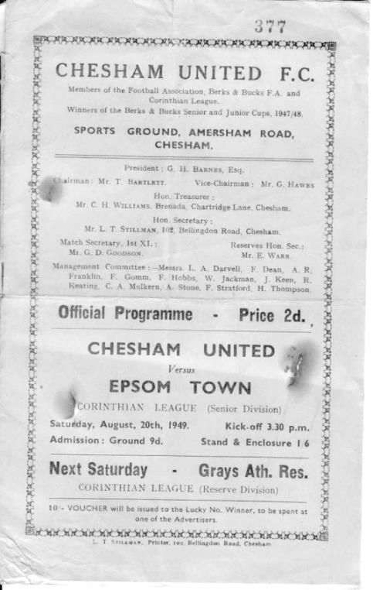
70 years ago today we made our debut in the Corinthian League, where we would remain until 1963 when it was merged with the Athenian and Delphian Leagues. Our first match was a trip to Chesham United where we secured a good 2-2 draw “in sweltering heat” with all four goals coming in the first half. Despite this result, it wouldn’t be until early 1952, some two and a half seasons later before we would actually win an away League match!! (see programme pictured – although we had been Epsom FC since 1934!)

59 years ago today we commenced our season with a Corinthian League Memorial Shield tie at home to Slough Town. We were the holders of the impressive Shield; effectively the League Cup, having defeated Maidenhead United at Wembley F.C. the previous April, but this match was drawn 1-1 and regrettably the replay seven days later was lost 5-2 at their old Dolphin Ground stadium. We had held the Shield for just 119 days!

35 years ago today we played our second match of the Surrey Senior League season and followed up Saturday’s 5-0 win over Lion Sports with a 6-0 win over Chessington United at Chalky Lane. Tommy Tuite scored four of the goals while Dave Ritman and another youngster with great promise, Trevor Lee, scored the other goals. Of course this particular season would be remembered mostly for our appearance at Wembley Stadium in the F.A. Vase, but it was to be very successful in a number of areas.

42 years ago today we played our first match as members of the Isthmian League, winning 2-1 at Feltham. That was back when their old ground, the Feltham Arena actually had a grass playing surface! At the end of the season we would be Division Two Champions, while Feltham would eventually reach Division One themselves, but hard times followed and they merged with Hounslow before losing their ground, then joining forces with the reformed Bedfont to become the Bedfont & Feltham we know today.

36 years ago today we opened our season with a league match against Boreham Wood for the second straight season. Last season it had all been about a late winner for our visitors and an even later penalty save by their keeper to preserve the points, but this time the drama happened at the start of the match as Steve Milton put us ahead after just 28 seconds. Steve Hill added a second later on and we held on to win 2-1, eventually earning promotion to the Isthmian League Premier Division at the end of the season for the only time in our history.

Centre page for results

Centre page for results

Godalming Town – History
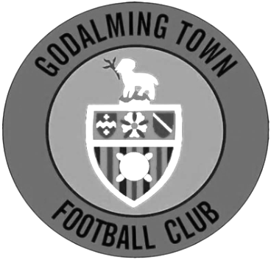
The club has its origins as Godalming United FC, formed in 1950 by ex-pupils of Godalming Grammar School.

Between 1950-71 the club played at the Recreation Ground. However, in 1970 Surrey Senior League side Farncombe collapsed, leaving their ground in Meadrow vacant. Godalming took over the debts and tenancy, changing their name to Godalming and Farncombe FC, and the ground to Wey Court in the process.

The original pitch was where the nearby Wey Court Sheltered Housing stood and considerable amount of work was undertaken on the new playing area, which was built on the site of an old waste tip. The club was helped by Waverley Council when drainage problems and subsidence meant they had to find a temporary home at Broadwater Park.

The club was accepted into the Combined Counties League for the start of the 1978 season, and a year later the name was changed again, to Godalming Town FC.

In 1985, another local club, Addlestone & Weybridge, was disbanded and, before their ground at Liberty Lane was demolished, Godalming purchased the stand and perimeter fence for £225 and £50 respectively. The stand was re-erected at Wey Court, with seating and fascia added.

The next development came in 1992 when the Guildford Football Appeal (formed in an attempt to return the towns name to senior football, following the collapse of Guildford City in 1977) donated a sum of money towards floodlights, and in return the name of the club was changed again to Godalming & Guildford FC.

Further recycling followed in 1995, when a new turnstile building was erected incorporating a turnstile from Millwall’s old ground and in 1996 the clubhouse was refurbished.

During 2005 close season, the club changed its name for a fifth time, albeit back to one of its previous incarnations, that of Godalming Town. A fantastic 2005/06 season saw the side take the Combined Counties League Championship and League Cup by storm. Godalming Town were then accepted by Isthmian League officials following extensive ground improvements.

At the end of a tough season, Godalming found themselves at the bottom of a very competitive division. However, events elsewhere meant that Godalming were reprieved from relegation and were transferred into the Southern League’s South & West Division for the 2007/08 season. Chuck Martini replaced Roger Steer as Manager in October 2007. Town were moved back to the Ryman League for the 2008/09 season and eventually finished in another record high position, 9th. Godalming also progressed further than ever before in the FA Cup by reaching the 3rd Qualifying Round before losing 2-1 at Conference South side Havant & Waterlooville.

The 2009/10 season was arguably the best season in the history of the club. Town finished a record high position 4th in the Ryman South but were eventually beaten 2-1 in the Playoff Final at Folkestone Invicta. The club progressed further than ever before in the FA Trophy and won the Surrey Senior Cup by beating Sutton United 2-1. The season also saw local boy Shaun Elliott became the club’s record appearance holder after reaching 360 games in a Godalming shirt.

Chuck Martini was replaced by joint-managers Jon Underwood & Neil Baker in October 2010 and the club finished an unpredictable season in mid-table. The 2011/12 season saw a lot of new faces join, but the team quickly gelled, reaching the 4th Qualifying Round of the FA Cup, beating Wimborne, Moneyfields, Worcester City & Bodmin before bowing out to Maidenhead United in front of 700 at Wey Court. The G’s finished 5th in the league, and travelled to Bognor Regis Town in the playoff semi-final, drawing 4-4 after extra time but Godalming lost 5-3 on penalties.

2012/13 saw Jon Underwood and Neil Baker guide Godalming to their highest ever finish in the pyramid, finishing in 3rd place. The G’s lost in the playoff semi-final for the second year running, this time losing 2-1 to Biggleswade at Wey Court. The season finished on a high however, as Godalming lifted the Surrey Senior Cup for the second time in four years, beating Sutton United 1-0 at Gander Green Lane, thanks to a last minute goal from Scott Harris. The close season saw Godalming moved to a third different league in as many years, this time to the South & West Division. With divisional change came a managerial change; Jon Underwood and Neil Baker left Godalming to join Slough Town, taking the majority of the squad with them. Andy Hunt was appointed manager in June 2013, assisted by Neil Selby.

The 2013/14 season was probably one of the hardest the club has dealt with. Andy Hunt was given the task of putting together a squad that will compete in the league and secure step four football. At Christmas 2013 the clubhouse, kitchen and changing rooms were ruined by flood water. Godalming finished the season in 18th position. Godalming were then moved into another division again and will play in Southern League Central Division for the 2014/15 season.

Godalming finished in 10th position in the 2015/2016 and reached the Surrey Senior Cup Final for the 3rd time but lost 4-0 to Merstham.

The 2016/2017 season could be viewed as an annus horibilis for the men as wins became less frequent than management changes. Andy Hunt left and was replaced by Dean Thomas who subsequently departed before the club was relegated under Dan Turkington. Inevitably relegation followed and Dan departed, as did much of the entire first team.

On the upside the Ladies team under the auspices of Steve Davies and , Darren Wheeler finished second in Division 2 South and were promoted to division one in the Greater London Womens Football League.

2017/18 began in familiar fashion with a new management and a new squad in a new division. After a promising start under Simon Funnell and Matt Drew (including a brief run in the FA Cup which finally ended at Hereford), wins became harder to come by and by Christmas, Jon Palmer and Gavin Smith were in charge. After a slow start, a promising run took the G’s out of the relegation zone before fixture congestion and a high turnover of players led to a second relegation in two years.

On a sad note in February 2018 saw the passing of Bill Kyte, the Godalming Town President of an astonishing 57 years. It is true to say that without his tireless work, the club would not even exist today which is why it is fitting that the name of the ground is now The Bill Kyte Stadium in memory of the great man.

2018/19 saw a change in management again and the club appointed former Southampton professional goalkeeper Les Cleevely and Jordan Knight as his assistant. Both of them bring plenty of coaching experience in senior and youth football. Jordan became first team goalkeeper with Jason Kerbey joining the management team as coach. Finishing 12th in Combined Counties League Division One.

Les has brought a refreshing blend of tenacity and commitment to the club, concentrating on building a young side that can grow and win together for years to come. He is tireless both on the field and behind the scenes and with selfless assistance, blood, sweat and beers of an incredible band of volunteer helpers, Les is helping rebuild the club to be in a position to challenge for honours again.

Godalming Town first team remain in the Combined Counties League Division One for the 2019/20 season, following relegation in 2018.

From behind the goal
Bagshot 2-1 Epsom & Ewell
Combined Counties League Division One - Saturday 10th August 2019

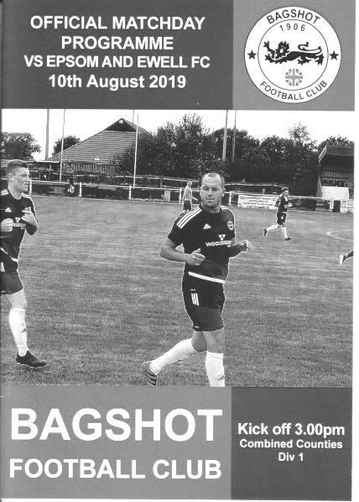
Salts fall to late rocket in uninspiring encounter

Our disappointing start to the season continued on Saturday when we were defeated 2-1 by Bagshot on a perfect playing surface at Camberley Town.

Incredibly we had seven different starters this week after our 5-3 defeat to Fleet Spurs with five of those seven absent for a number of reasons. The other two, Ashley Thompson and Liam Roberts dropped to the bench while Joe Bonass-Ward made his debut while Rory Smith and Billy Carney made their first starts for the club. Also making their first starts of the season were Jake Robinson, Scott and Todd Murphy and Taryn Smith.

We went up the hill at Krooner Park but with a strong wind behind us and both teams took a bit of time to get the hang of the playing conditions. Smith made an early chance with a deep left wing cross which reached Toby Funnell at the far post, but his header back across the Bagshot keeper Lee Allen was just beyond the far post. A Lewis delivery skimmed the bar in the ninth minute, while within sixty seconds he was back to make an important block for a corner.

The home side started to fashion some chances too and a nice bit of passing resulted in a shot that fortunately was straight at Felix Davies before Jordan Gallagher was somewhat harshly the recipient of a yellow card after mistiming a challenge from around the side. He would be fouled on numerous occasions in this match and three yellow cards would be awarded for fouls against him.

The home side had the ball in the net in the 24th minute but the close range finish was ruled offside before Funnell made a good run and cut inside, but spoiled his work by shooting from distance with his weaker left foot with other options available and the effort dribbled towards the keeper.

A more powerful strike on goal came from Smith in the 37th minute after good work from Carney and Gallagher and Allen parried the low drive for a corner and although the set piece was cleared we were beginning to finish the half as the stronger of the two teams. Funnell's free kick was into the wall but it rebounded to him again, only for

his next strike to hit Gallagher and divert for a throw. It might have been sneaking just inside the post too!

As we reached the 45th minute a Gallagher free kick was wasted as his delivery sailed over everyone on this windy day and out for a goal kick. I shouted that he would have been better having a shot in these conditions and I've no idea whether he heard me, but three minutes into injury time he had another free kick and this time curled a beauty from the edge of the box, dipping over the wall and into the corner of the net to give us a lead that was probably just deserved on the basis of our stronger finish to the half.

But for the second week running we went backwards in the second half. Having done the hard work to get ahead, we started to get pushed back and had a scare in the 58th minute when a near post corner was headed just wide of our post, but we didn't heed the warning and a minute later we lost possession in midfield and the ball was instantly fed behind our defenders where Alex Jeffers was able to reach the ball and send it across Davies; the ball going in off our far post.

Bobby Bennett and Liam Roberts entered the match at this point but the problems continued at the other end as we contrived to send Jordan Merriman clean through on goal where Davies stood up well and blocked the shot. It was a lucky escape and it was their turn to be concerned shortly afterwards as a deep free kick into the Bagshot area was punched away, but only to Scott Murphy who headed the ball back in and Connelly diverted it goalwards, although a defender was back to clear the danger.

Chances started to appear at both ends and Davies tipped over a cross from a short corner that we had completely switched off for, before at the other end Smith set up Bennett for a low drive, but Allen kept the ball out at the near post with his foot. From the corner there was a scramble with Todd Murphy getting a half chance but the keeper half smothered the effort and the fell on the ball. Gallagher was just wide with another free kick before the hosts sent a good left wing cross into the box which was headed just over the bar. However, as we entered the first minute of injury time Merriman was well wide but decided to have a shot and it flew into our top corner at pace for what proved to be the winning goal.

It was certainly a finish deserving of winning any match, but we have to ask ourselves how we managed to lose our way after leading but losing yet again, something we have now done in our last three consecutive league matches dating back to last season.

Epsom & Ewell: Felix Davies, Rory Lewis, Joe Bonass-Ward, Jake Robinson, Todd Murphy, Lloyd Connelly, Toby Funnell, Scott Murphy (c), Billy Carney, Jordan Gallagher, Taryn Smith

Subs: Liam Roberts for Carney (64), Bobby Bennett for Lewis (64)

From behind the goal
Westside 1-3 Epsom & Ewell
Combined Counties League Division One - Saturday 17th August 2019

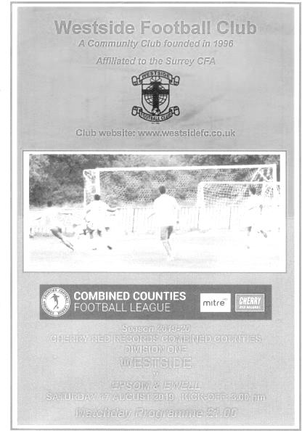
Salts get on the board at Chalky Lane

After two disappointing League results, a much improved performance earned us our first three points of the season as we thoroughly dismantled a willing but somewhat inexperienced Westside team, who in all honesty were fortunate not to lose by a heavier margin.

Of course it wouldn't be an Epsom match without the obligatory scare and our inability to take chances nearly cost us when the hosts drew level towards the end, but our lads deserve credit for digging deep to restore the lead almost immediately and a superb solo goal from substitute Liam Roberts was the icing on the cake.

Going into this match Westside had won twice without conceding to sit joint top of the table, but their 100% record was looking vulnerable as early as the sixth minute when we earned a free kick outside the penalty area, although it was at a very wide angle. However Adam Heagney's 6th minute set piece was well placed for Chaz-Lee Martin to rise and send a thumping header into the net from close range to register his second goal in two matches. From early performances I had hoped that he may be able to help out with half a dozen goals this season, but I may have to revise that target upwards!

Jordan Gallagher was very close with a free kick as he attempted to repeat his heroics of the week before from a similar position, but this one went just the other side of the post and a few minutes later he saw his curling goalbound shot tipped wide for a corner by Giordano Zabotti. Despite being involved in a lot of our attacks it just wasn't his day, being replaced by Rob Hendry later on.

The hosts were struggling to make any chances although a dipping strike just cleared our crossbar after 20 minutes and we had another concern five minutes later when Scott Murphy was the recipient of a clumsy challenge and limped off with a calf injury. Fortunately we had a very strong looking bench for this match and Sean White came on for his first start following a pre-season injury with Martin taking the Captain's armband.

We continued to dominate and Jake Robinson was next to strike but his shot on target

was blocked and White's follow up from 20 yards was cleared. Bobby Bennett then saw his shot deflected over the bar, while his next low cross was tapped in at the far post by Taryn Smith only for our striker to be ruled offside. We then had another warning when Felix Davies had to stand up well to deny Michael Tia as he had run through a gaping hole in our defence.

This wouldn't have been a concern if we had been three or four goals up as we should have been, but for all our domination we had seemed to struggle in the danger area and having led but lost in our previous three league matches, our failure to put the match to bed in the first half was a worry as we had around 80% of the possession but had only forced the keeper into one challenging save. Going down the hill and with a slight wind behind us we started where we had left off in the previous forty-five minutes with Smith seeing his shot blocked and Joe Bonass-Ward having a cross tipped over the bar.

Sean White was close with a snap shot from the edge of the box with his left foot which went just beyond the post and Gallagher and Bonass-Ward both had shots on target that lacked power as we were unable to finish this game off. Then in the 73rd minute and with one of their very few chances Westside equalised. A free kick was delivered to the near post and the low shot from 12 minutes crept in at the near post.

This was really frustrating and it would have been easy for the heads to drop at this stage, but we were still holding the majority of possession and chances and within three minutes we were back in front as Robinson cleverly beat the offside trap with a run from deep and he was through on goal down the left hand channel. He cut in and his strike across goal was well saved but Smith was on to the loose ball quicker than the defenders and he forced the ball in from six yards, hitting the ball down and up into the net in the 76th minute.

One further scare came in the 81st minute when a long range strike cannoned off our crossbar and back into play but we sealed the points in the 85th minute with a superb individual goal from Roberts who received the ball out on the touchline some thirty yards out, but beat the two men close to him before running to the goal line, then cutting back onto his right foot and drilling the ball low just inside the near post from eight yards.

This was a vast improvement on previous performances this season and gave supporters a clear indication of what this team is capable of when it is playing well. The target for the players now is to replicate this sort of performance every week and to put a few more chances away would make matches like this a little more comfortable for everyone.

Epsom & Ewell: Felix Davies, Adam Heagney, Joe Bonass-Ward, Jake Robinson,
Chaz-Lee Martin, Lloyd Connelly, Toby Funnell, Scott Murphy (c), Taryn Smith,
Jordan Gallagher, Bobby Bennett

Subs: Sean White for Murphy (24), Liam Roberts for Funnell (69),
Rob Hendry for Gallagher (77)

Match and Ball Sponsorships – 2019/20
Opponent | Date | Match Sponsor | Ball Sponsor
Fleet Spurs | 03/08/19 | Club President - Stella Lamont
Godalming Town | 20/09/19 | Paul Merritt
Tooting Bec | 27/09/19
Kennington (FAV) | 31/08/19
AFC Hayes | 21/09/19
Farnham Town | 28/09/19
FC Deportivo Galicia | 19/10/19
Kensington & Ealing Borough | 26/10/19
Sandhurst Town | 09/11/19
Dorking Wanderers Res | 23/11/19
Bedfont & Feltham | 14/12/19
Westside | 28/12/19
British Airways | 11/01/20
Cove | 25/01/20
Ash United | 08/02/20
Chessington & Hook United | 22/02/20
Eversley & California | 21/03/20
Walton & Hersham | 31/03/20
Bagshot | 04/04/20
Jersey Bulls | 13/04/20
Unknown  (Surrey Premier Cup) |  | Might be at home – date unknown
Match sponsorship costs just £60.00!

Sponsorship includes:

Admission, programmes and hospitality for three people.

A full page advert in the programme and mascot for the day (if required).

Also, you get to choose the player of the match, who will receive a prize

If you are interested, just speak to a Committee Member,
or drop me an email at: richard.c.lambert@gmail.com

Combined Counties League – Division One
Tuesday, 20th August 2019 - Kick-off 7.45 p.m.
Epsom and Ewell  (Royal Blue & White hoops) | V |  | Godalming Town  (Yellow / Green)
Squad | NUMBERS |  | Squad
Felix Davies |  |  | Jordan Knight
Josh Woodcock |  |  | Ethan Kaiser
Reisse Griffin |  |  | Dominic Hardisty
Adam Heagney |  |  | Rory Sellick
Lloyd Connelly |  |  | Curtis Osano
Chris Head |  |  | Joe Lewis
Chaz-Lee Martin |  |  | Kenny Kasibante
George Brown |  |  | Jake Heard
Joe Bonass-Ward |  |  | Oliver Stevens
Louis Chin |  |  | Darren Wheeler
Todd Murphy |  |  | Jack Cleevely
© Scott Murphy |  |  | Francis Sey
Sean White |  |  | Liam Gadd
Bobby Bennett |  |  | Jack Stow
Jake Robinson |  |  | Adam Bicknell
Rory Lewis |  |  | Matthew Kerbey
Joshua Caulcrick
Ashley Thompson
Rob Hendry
Taryn Smith
Ben Chick
Kyle Carton
Toby Funnell
Jordan Gallagher
Liam Roberts
Billy Carney
Simon Funnell | MANAGER |  | Les Cleevely
 | ASSISTANT |  | Jordan Knight
Sam Morgan | COACHES |  | Jason Kerbey
Chantelle Farrell | PHYSIO |  | Rebecca Peacock
REFEREE: J.Amadori
ASSISTANTS: P.Crichlow, P.Maskell
Today’s Match and Match Ball are sponsored by:
long-serving supporter Paul Merritt

OUR NEXT VISITORS TO HIGH ROAD
Tooting Bec
Cherry Red Combined Counties League – Division One
Tuesday, 27th August 2019 – Kick-off – 7.45 p.m.

